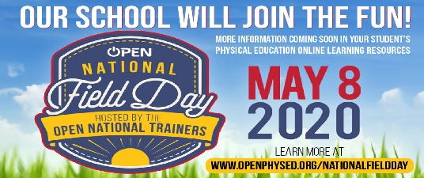
Hello Cobb County Students and Families,
The OPEN National Field Day event is Friday, May 8th!
Field Day is an important tradition at our school. It is a significant day for our students and our staff, and we feel that in these incredibly challenging times this national event is a unique way that we can stay connected as a community and support one another in a fun and meaningful way.
All #NationalFieldDay events are designed to be done indoors or outdoors using common household items. You won’t be asked to purchase any specialized equipment or supplies. May is also National Physical Fitness & Sports Month! This is a great time to participate in some Fun Family Fitness!
Over 54 Cobb County Schools have registered for this national event. Here is how you can participate with us!
April 27th – May 4th – Practice Time!
- Log on and practice the “Family Dance Challenge - Keep Your Head Up” video created by: Kelly Mattingly of Ford Elementary School (https://www.youtube.com/watch?v=ruIEuz8ih0w&t=181s)
- Choose at least 5 activity cards. Of course, you can choose more (https://openphysed.org/wp-content/uploads/2020/04/NFD2020-ALL-EventCardsV2.pdf)
- Watch demonstration videos of several of the activity cards (https://openphysed.org/fielddayvideos)
- Practice your favorite activities for National Field Day Week
May 4th – May 8th Share Your Pictures and Videos! Letitia.horne@cobbk12.org
- Share pictures and videos of the game activities you and your family chose with your PE Teacher Coach Horne
- Share your dance version of the “Family Dance Challenge - Keep Your Head Up” video with your pe teacher
- Tag us on social media: @cobbhpe and @cobbschools
- From May 3rd thru 7th, we will follow #NationalFieldDay and watch the Field Day Torch travel across the country in preparation for the main event.
- On May 8, our entire school will participate in events, complete an official score card (optional), share photos and videos through our school’s approved platforms, and participate nationally on social media using #NationalFieldDay.

Cobb National Field Day Spirit Week – Join Us!
- Monday May 4th – Exercise Day – (Share a picture or video of your favorite exercise)
  - A schedule will be shared of the National Field Day Week which will include a virtual torch run, opening ceremonies and a National Field Day Social Media Schedule from Openphysed
- Tuesday May 5th – Healthy Snack Day (Share a picture of your favorite snack)
- Wednesday May 6th - Career Day – (Share a picture of your future career)
- Thursday May 7th – School Spirit Day – Wear a school shirt or your school colors
- Friday May 8th – Family Game Day (Share a picture of your favorite family game)
We will send you updates on this fun and festive event. We appreciate your cooperation and are hopeful that your entire family will use it as a fun and meaningful way to be physically active together and with our entire school community.
Stay well,
Letitia Horne
Health/Physical Education
Lindley Sixth Grade Academy

